Algebra IA Name _________________________________ 2.3 Worksheet Date ___________________ Hour ______

Solving Multi-Step Equations
Tell whether the given number is a solution of the equation.
1. 6x + 1 – 5x = 7; 2 2. 7 + 2(m – 4) = 3; 1 3. $\frac{1}{2}\left(8x−6\right)=1$; 1

Find the value of x for the triangle or rectangle.
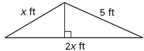
4. Perimeter = 17 feet 5. Perimeter = 18 meters

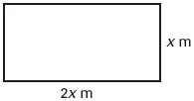

Solve each equation.
6. 3a + 2a + 7 = 12 7. 9n – 4 + n = 16 8. 7c + 3 – 5c = 15

9. 16 – 3y + 4y = 27 10. 2 + 3(x + 1) = 17 11. 15 + 4(m – 2) = 21

12. 2p + 3(p + 3) = 21 13. 6w + 5(w – 2) = 23 14. 7 – 3(x + 2) = 4

15. $\frac{1}{4}\left(d−5\right)=1$ 16. $\frac{1}{3}\left(m+6\right)=4$ 17. $\frac{1}{8}\left(w−7\right)=5$

